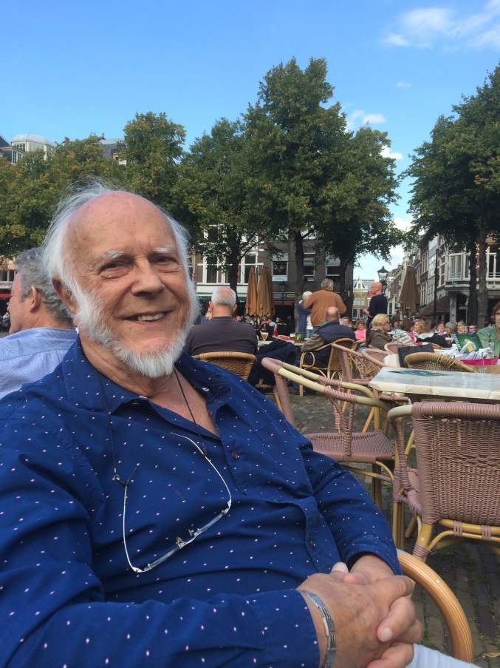
John Rowan
31st March 1925 – 26th May 2018
Funeral Arrangements
When: Friday June 22nd at 1 pm
(aim to arrive between 12.30 and 12.45. Refreshments available on arrival).

Where:
Green Acres Epping Forest
Kiln Road
North Weald Bassett,
Epping
CM16 6AD
https://www.greenacrescelebrate.co.uk/park/epping/

Green Acres is a Woodland Burial Site. After the service, there will be a little walking through the forest to the burial site. Transport by buggy is available for those who need it.

Reception After the Burial:
There will be a short reception nearby, from about 3.30 pm, with light refreshments available. If you would like to attend this, please RSVP right away to: sjrowan@virginmedia.comWe will let you know about the venue in good time. We need to know the number of people attending the reception so that we can pass that on to them.

How to get there:
By public transport: to Epping (Central Line) Take a taxi from there (available at the station).

By car: There is plenty of parking on site.

If you are travelling by car, it would be very helpful if you could offer a lift to anyone wanting to attend the reception, or return to the station.

Flowers
John preferred uncut flowers so large floral tributes are not encouraged. If you wish to bring a small floral offering, please ensure that it doesn’t contain any plastic as all flowers will be left on the grave for the deer to nibble.

Donations
If you would like to make a donation . . .

MIND: https://www.mind.org.uk/get-involved/donate-or-fundraise/donate/
Woodland Trust: https://www.woodlandtrust.org.uk/support-us/

Dress
John liked colourful clothes, so be as colourful as you feel comfortable with.

